

Samharam Bilingual Private School focuses on our students' overall development of their personality-psychological Intellectual, Spiritual, Emotional motor skills and during the course of their education to discover their inner strength first through encouragement and practice in a safe learning environments for their life inside and outside the school.

### MISSION

### To prepare positive result-oriented graduates through integrated education.

### VISION

### To be the best school in Oman with global standards.

### SAMAHRAM BILINGUAL PRIVATE SCHOOL

Samharam School entertains and gives opportunities for the school children to participate in many extra-curricular activities and decision-making partnerships. Our school has done well in all activities and has participated in many external programs and events. Samharam Bilingual Private School has maintained a commitment to providing the highest level of instructional and basic educational experience to students of different ethnicity in the Dhofar Region.

### CHAIRMANS MESSAGE

*Welcome to the website of Samharam Bilingual Private School and thank you for being part of our institution. What we have come to realize is that our school represents more than just a place for primary and secondary education. From the earliest days of its establishment, our school was founded with a specific mission to serve. This mission guides our staff and students to achieve our vision, that is, "To be the best school in Oman with global standard". This vision will serve as our reference upon which all the school's plans shall be based and will further inspire us to be enthusiastic in offering the highest standard of education in the region. you are welcome to browse our website and we hope you will see for yourself the remarkable and extraordinary work our school represents, our facilities, our upcoming activities as well as how our school functions to achieve our mission and vision. we wish you success and you are all welcome to send us your comments, suggestions, and any ideas that may contribute directly in the improvement of our school.*

#### Dr. Ahmed Ali Al-Mashani

Chairman

OUR FACILITIES:

**TRANSPORTATION**

The school provides transportation service for parents who don’t have the time to drop and pick up their child due to busy schedule. A bus supervisor accompanying the students to make sure that all students are safe, and invest their time inside the bus engaging in Zikr and narration of stories, considering the period of their presence within the bus as an extracurricular study period.

### VIDEO

The school prepares students who participate in the press and the media and they are trained and encouraged in media writing and creativity through the school broadcast and the electronic and wall press. The school provides an opportunity for students to take part in the school broadcast during the morning assembly and in public events and ceremonies.

### 

### SPORTS

Samharam School entertains and gives opportunities for the school children to participate in many extracurricular activities and decision making partnerships. Our school has done all activities and has participated in many external programs and events. Samahram Bilingual Private School has maintained a commitment to providing the highest level of instructional and basic educational experience to students of different ethnicity in Dhofar

### LIBRARY

Concept Center Resource Learning:  
A learning environment that simulates multiple types of information sources.  
The importance of learning resource centers:  
– Provides a suitable environment that enables the student to use a variety of resources.  
– Assist in organizing and categorizing

Educational resources for easy

### LABS

The school believes that students will learn, remember and understand more in science and computer if they have access to undertake experiments and computer facilities.

### EXTRA CURRICULAR ACTIVITIES

Samahram School adopts a comprehensive plan for extracurricular activities that allows all its students to engage in free activities through which they express their creative energies and talents in a free creative atmosphere. [**Read More**](https://samharam.edu.om/extracurricular-activities/)

## LATEST NEWS

1.My Khareef Creative from 1st July to 31st July. Best Wishes of your Time at Home.

- Summer Courses

2.Summer Courses conducting on July 1st students can participate by App.

- ZOOM

## OWNER'S

Owner's at Samharam Bilingual Private School

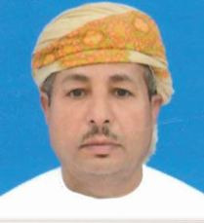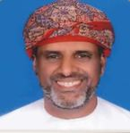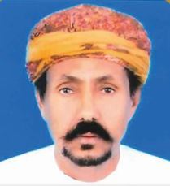

Mr. Salim Ali Amer Jeed

Dr. Ahmed Ali Al Mashani

Mr. Salim Mubark Al shanfari

**About us**

**BRIEF HISTORY OF THE SCHOOL**

Throughout its history, Samharam Bilingual Private School has maintained a commitment to providing the highest level of instructional delivery and basic educational experience to students of different ethnicity in the Region of Dhofar. Founded in 1999, it started with only 60 students and 6 staff in its first School building located in Auqad, Salalah. To accommodate the growing number of students,procured landmark and constructed the modern school building in the new campus located beside Al Bahaja supermarket in Al Saadah.

Dedicated to reaching the highest standard of education, Samharam became the first School in the Region to be licensed and affiliated by Cambridge Assessment International Education in UK in 2008. It then started delivering its Science, Mathematics, Computer and English subjects using the Cambridge curriculum which became a big bond and responsibility since as a Cambridge Assessment International school, the School must meet the highest level of Cambridge Education. So the School started to standardize and regulate its physical and learning resources as well as its staff to assure that the quality required is met for the Cambridge approval.

Samharam Bilingual Private School, which got its name in reference to the ancient historic city located in Taqah, East of Dhofar, now has a dedicated faculty of 78 full-time teachers, and many of them have advanced degrees in their fields. It continuously provides an extraordinary range of educational experience both inside and outside of the classroom and has now made its mark in the region as one of the best private schools.

### CAMBRIDGE AFFILIATION

Samahram Bilingual School is the first school in Dhofar Region to be affiliated with Cambridge.In 2008, the school got the license to offer the Cambridge Primary Program for classes 1-6. In the succeeding years, the school applied for the Cambridge Secondary Program for classes 7-8. From then on, the school conducts the Cambridge Primary and Secondary Checkpoint assessment for classes 6-8. The school has the approval from the Ministry of Education in Oman to offer IGCSE program from the old building. In the school year 2017-2018, with its new building equipped with 3 modern science laboratories and learning resource center with lots of books as supplementary materials for the students, the school will apply to Cambridge to offer the IGCSE program for classes 9-10.

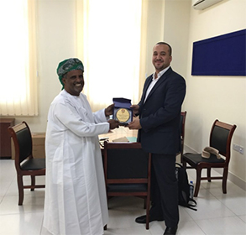

[BOARD OF TRUSTEES](https://samharam.edu.om/about-us-3/#team_2)

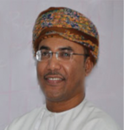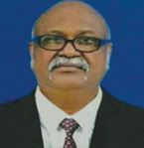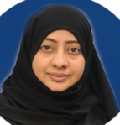

Ms. Zainab Ali Al shanfari

Mr. Salah Mohammed Bashir

Ms. Wafa Abdullah Al Najjar

Eng. Mohammed Saeed Al-Mashali

Dr. Yasser Bashir Obaidoun

Mr. Said Aslam Al Daan

Mr. Amjad Ali

Dr. Ahmed Ali Al Mashani

[BOARD OF COUNCIL](https://samharam.edu.om/about-us-3/#team_1)

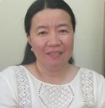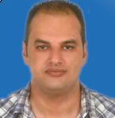

Mr. Rammy Mohammed Amer

Ms. Lorraine Manipan Chua

Mr. Salah Mohammed Bashir

Mr. Amjad Ali

Ms. Zainab Ali Al shanfari

Dr. Ahmed Ali Al Mashani

## SCHOOL TIMINGS

Students:

KG 1 – KG 2

School starts at 08.00 am â€ “Ends at 12:00 pm

GRADE 1 – 12

School starts at 07.20 am â€ “Ends at 02:00 pm

[ADMINISTRATION STAFFS](https://samharam.edu.om/about-us-3/#time_2)

School starts at 07.00 am â€ “Ends at 2:00 pm

[ACADEMIC STAFF](https://samharam.edu.om/about-us-3/#time_3)

School starts at 07.00 am â€ “Ends at 2:00 pm

## SCHOOL UNIFORMS

Throughout its history, Samharam Bilingual Private School has maintained a commitment to providing

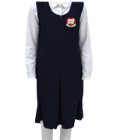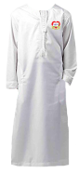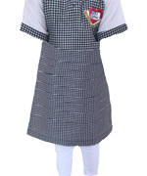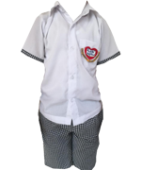

### GRADE 1 TO 10 (GIRLS)

### PRE – PRIMARY(BOYS)

### GRADE 1 TO 12 (BOYS)

### PRE – PRIMARY (GIRLS)

## CURRICULUM

## SIX ‘E’ APPROACH TO EDUCATION ENGAGE, EXCITE, EXPLORE, EXPLAIN, EXPAND AND EVALUATE.

* 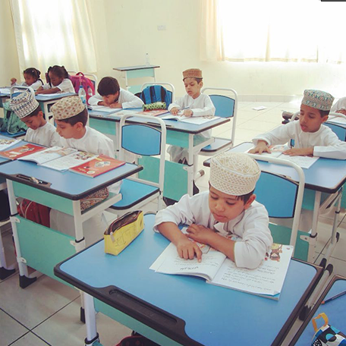Visual Thinking
* Contextualization and Application
* Active Learning: Creating Excellence in the Classrooms
* Digital Labs and Simulations
* Teaching - learning outside the classroom - study tours
* Contextualization and Application
* Co-operative Group Learning
* Warm-up Activities and Puzzles
* Mental Activities in the Classroom

## TECHNOLOGY INTEGRATION

Samharam Bilingual School is the first school in Dhofar Region to be affiliated with Cambridge. In 2008, the school got the license to offer the Cambridge Primary Program for classes 1-6. In the succeeding years, the school applied for the Cambridge Secondary Program for classes 7-8. From then on, the school conducts the Cambridge Primary and Secondary Checkpoint assessment for classes 6-8. Although, the school has the approval from the Ministry of Education in Oman to offer IGCSE program from the old building. In the coming school year 2017-2018, with its new buildings equipped with 3 modern science laboratories and learning resource center with lots of books as supplementary materials for the students, the school will apply to Cambridge to offer the IGCSE program for classes 9-10.

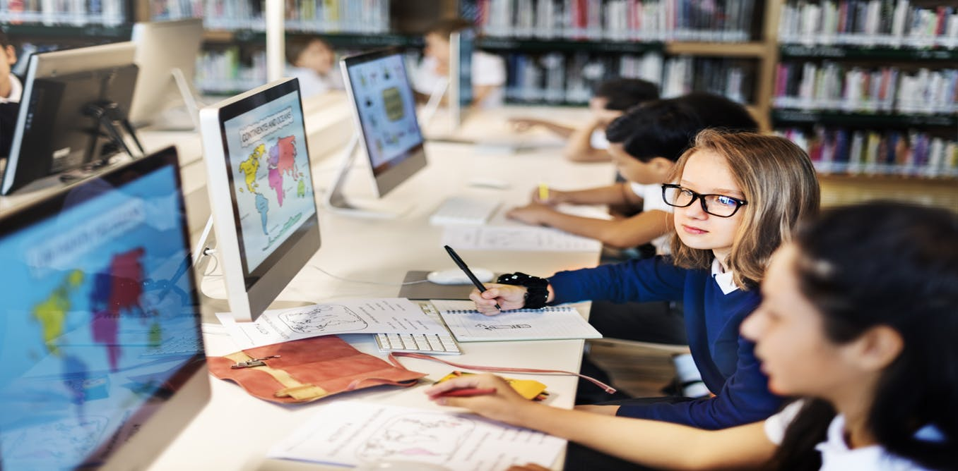

## PROGRAMS

Samharam Bilingual School is the first school in Dhofar Region to be affiliated with Cambridge.

Pre Primary| Primary |Secondary

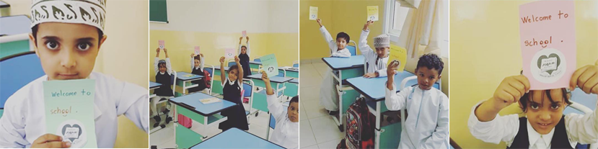

Samharam Bilingual School is the first school in Dhofar Region to be affiliated with Cambridge. In 2008, the school got the license to offer the Cambridge Primary Program for classes 1-6. In the succeeding years, the school applied for the Cambridge Secondary Program for classes 7-8. From then on, the school conducts the Cambridge Primary and Secondary Checkpoint assessment for classes 6-8. Although, the school has the approval from the Ministry of Education in Oman to offer IGCSE program from the old building.

**SBS Kindergarden program strongly believes and aims at:**

* Ensuring each child is valued, respected, feels safe and secure and develops a positive self-concept
* Enabling a sound foundation for physical and motor development of each child- as per each childâ€™s potential
* Imbibing a good nutrition routine, health habits, hygiene practices and self-help skills.
* Enabling children for effective communication and fostering both receptive and expressive language.
* Promoting development and integration of the senses.
* Stimulating intellectual curiosity and developing conceptual understanding of the world around by providing opportunities to explore, investigate and experiment.
* Enhancing development of prosocial skills, social competence and emotional well-being.

## ADMISSION

## ADMISSION

### ADMISSION RELATED LINK

##### General Conditions for Students applying to KG1 TO G12 :

* Have to pass the Psychometric test

##### Student applying for Grade 2 onward :

* Have to come from schools where English is the primary teaching language
* Have to pass the Psychometric and Academic tests

##### Fourthly: Required documents

* 4 Photos.
* A copy of the guardian identity card or passport.
* A copy of the student identity card or passport.
* A copy of certificate of vaccination.
* A copy of birth certificate. (Documented by the Omani Embassy for Non-Omani)
* A copy of Medical examination certificate
* A copy of last school certificate. (Documented by the Omani Embassy for Non-Omani)

**NEW APPLICATION new**

## ACTIVITIES

**Activities**

Samahram School adopts a comprehensive plan for extracurricular activities that allows all its students to engage in free activities through which they express their creative energies and talents in a free creative atmosphere. During the group activities, the school is currently adopting the following projects:  
**Artistic and Creative Activities:** All students are allowed to practice creative art. They are motivated and trained by specialized activity groups.  
**Theater:** The formation of theater and other organizational teams train those involved in the refinement of their creative talents.  
**The School Press:** The school prepares students who participate in the press and the media and they are trained and encouraged in media writing and creativity through the school broadcast and the electronic and wall press.  
**The School Broadcast:** The school provides an opportunity for students to take part in the school broadcast during the morning assembly and in public events and ceremonies.  
**The Small Inventor Project:** This project is designed to encourage students to demonstrate their innovative abilities in the field of inventions and scientific creations.  
**Plan For your Life:** This program aims to encourage students to plan for their future and simplify the skills of self-planning through the brochure designed and distributed to all students of the school from the kindergarten to the General Certificate levels, taking into account the characteristics of mental, psychomotor, emotional and dynamic development for each stage.  
**Project of the Year:** The school trains its students to complete study projects in coordination with classroom educators and activities supervisor and educational counselor in order to equip students with the skills of scientific thinking and to familiarize them with experimental thinking, research writing, analytical and reasoning skills.

## FACILITIES

## TRANSPORTATION

The school provides transportation service with a bus supervisor accompanying the students to make sure that all students are safe, and invest their time inside the bus engaging in Zikr and narration of stories, considering the period of their presence within the bus as an extracurricular study period.



## LIBRARY

A learning environment that simulates multiple types of information sources. The importance of learning resource centers: - It provides a suitable environment that enables the student to use a variety of resources. - Assist in organizing and categorizing educational resources for easy access. - Assists the teacher through the Secretary of the Center in the preparation and implementation of the class and reorganization of educational resources used and arranged and ensure its readiness for the next times. Objectives of Learning Resource Centers. - Support the curriculum by providing learning resources related to the curriculum, in order to stimulate effectiveness. - Develop the skills of research, exploration, thinking and problem solving of the learner. - Providing the learner with the skills and tools that enable him to adapt and benefit from the rapid developments in information systems. - Meet the needs of individual differences by provided Services Learning Resource Center. - Providing different sources of information related to educational needs. - Assist students and teachers and train them to use information sources. - Provide facilities that help the teacher to produce simple teaching aids.

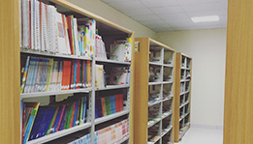

SPORTS

Samharam School entertains and gives opportunities for the school children to participate in many extracurricular activities and decision making partnerships. Our school has done all activities and has participated in many external programs and events. Samahram Bilingual Private School has maintained a commitment to providing the highest level of instructional and basic educational experience to students of different ethnicity in Dhofar Region.

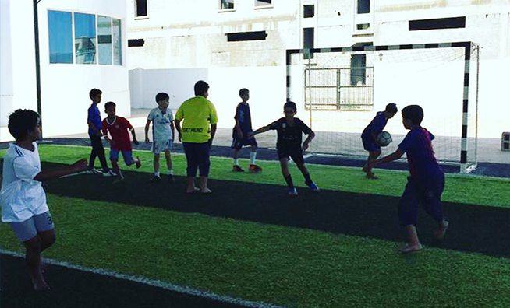

## PRAYER ROOMS

The school values the importance of saying prayers. For this reason, students are required to learn to pray at the scheduled time in the specific praying area. Individual students are assigned to lead the prayer chosen by the teachers. The prayer is conducted in an open yard and there is a separate prayer room for female students and staffs. Noon prayer is conducted in a congregation for male students in the open yard.

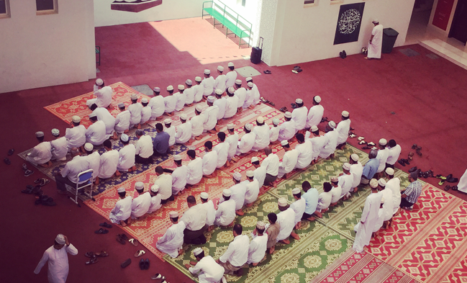

COMPUTER LAB

The school believes that students will learn, remember and understand more in science and computer if they have access to undertake experiments and computer facilities. There are three science laboratories available to achieve this goal. There are two Computer labs separate for boys and girls, each with a capacity for 25 students. The laboratories have already passed the standard set by the Ministry of Education(Oman) and Cambridge Assessment International Education. Computers are available in the ratio of one-to-one.

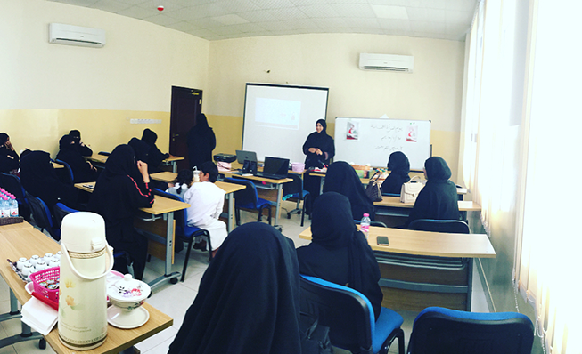

## SMART CLASSES

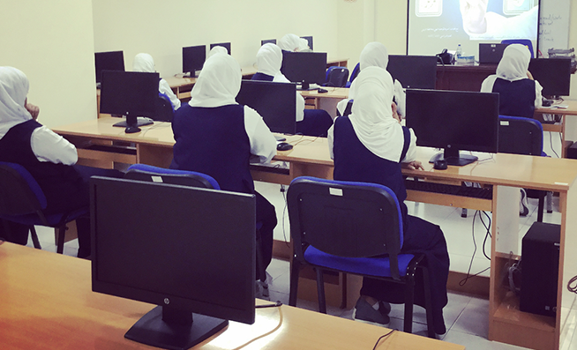Our computer labs provide a computing device for every student. Every system is connected with highly equipped networks with internet and firewall. While access to technology is changing their function, computer labs remain relevant in today’s schools for a number of reasons. Our computer labs are highly structured learning environments where students can prepare for a tech-heavy future. The impact of mobile computing on education is indisputable. These powerful devices caused a sea change on par with that of the microcomputer, which launched the first school computer labs. Accessibility to computing power is no longer constrained by time and place.

## EXTRA CURRICULAR ACTIVITIES

Samahram School adopts a comprehensive plan for extracurricular activities that allows all its students to engage in free activities through which they express their creative energies and talents in a free creative atmosphere. During the group activities, the school is currently adopting the following projects: **Artistic and Creative Activities:** All students are allowed to practice creative art. They are motivated and trained by specialized activity groups. **Theater:**The formation of theater and other organizational teams train those involved in the refinement of their creative talents. **The School Press:** The school prepares students who participate in the press and the media and they are trained and encouraged in media writing and creativity through the school broadcast and the electronic and wall press. **The School Broadcast:** The school provides an opportunity for students to take part in the school broadcast during the morning assembly and in public events and ceremonies. **The Small Inventor Project:** This project is designed to encourage students to demonstrate their innovative abilities in the field of inventions and scientific creations. **Plan For your Life:**This program aims to encourage students to plan for their future and simplify the skills of self-planning through the brochure designed and distributed to all students of the school from the kindergarten to the General Certificate levels, taking into account the characteristics of mental, psychomotor, emotional and dynamic development for each stage. **Project of the Year:** The school trains its students to complete study projects in coordination with classroom educators and activities supervisor and educational counsellor in order to equip students with the skills of scientific thinking and to familiarize them with experimental thinking, research writing, analytical and reasoning skills.

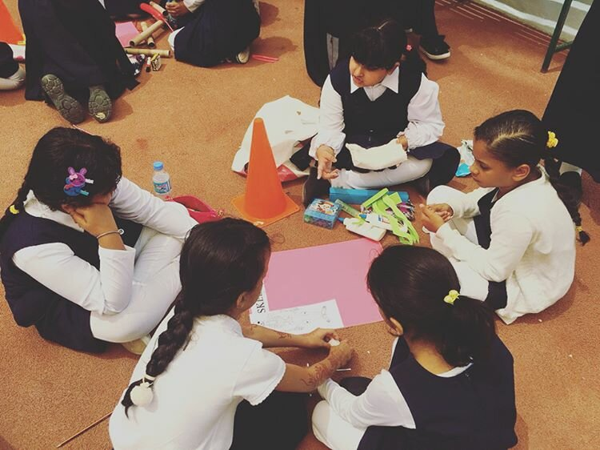

## PHOTOS & VIDEOS

### C:\Users\megdadmin\Downloads\khyar\11.jpgC:\Users\megdadmin\Downloads\khyar\13.pngPHOTOS

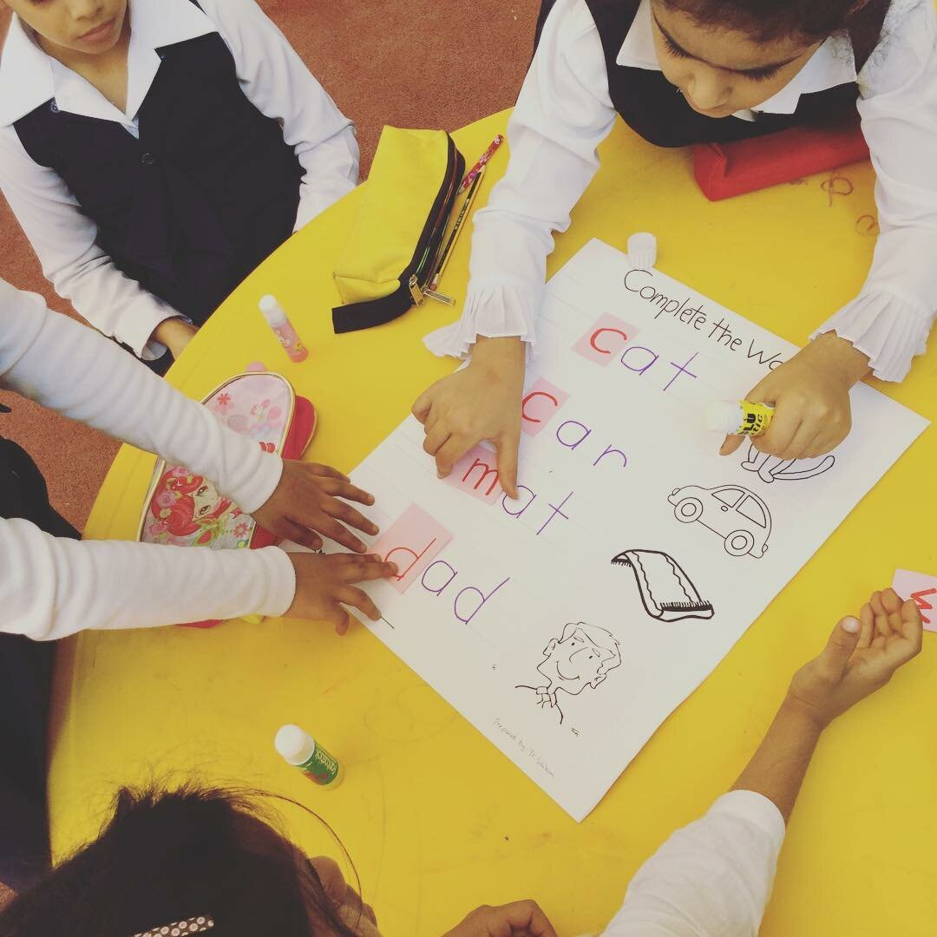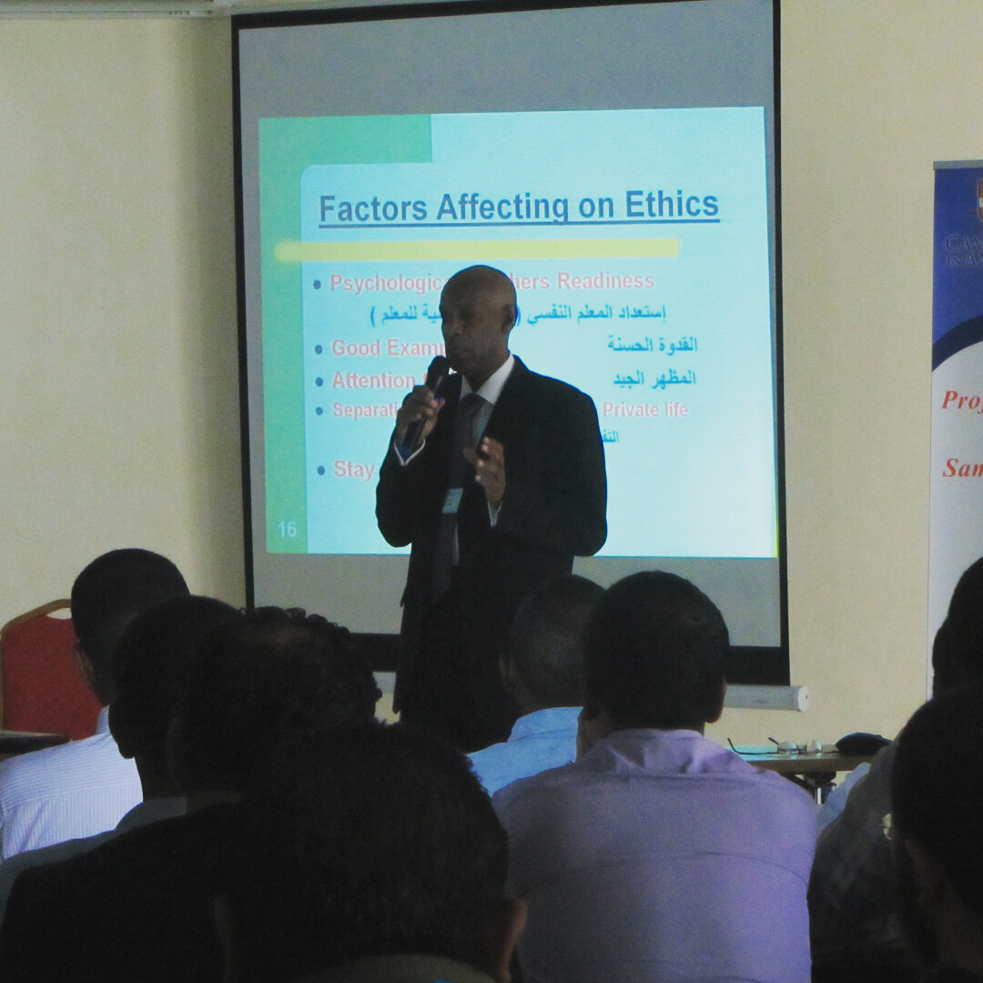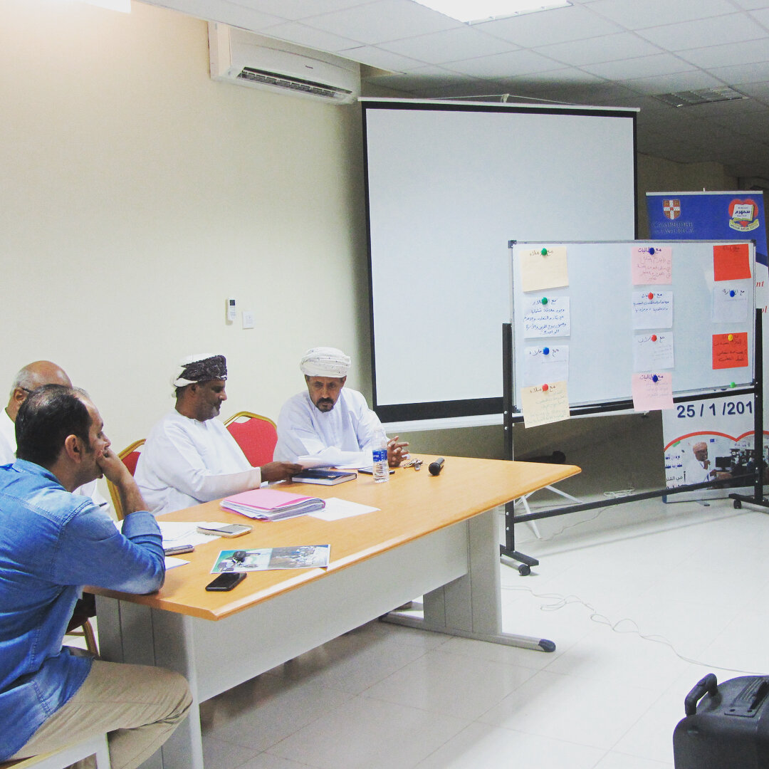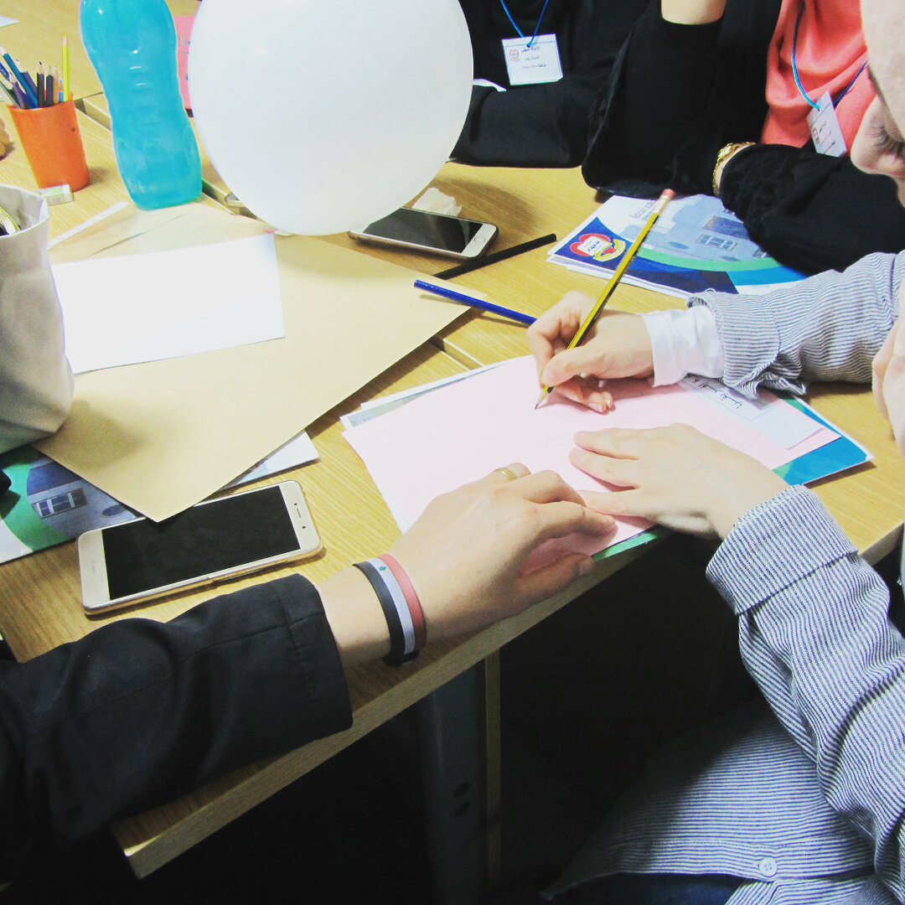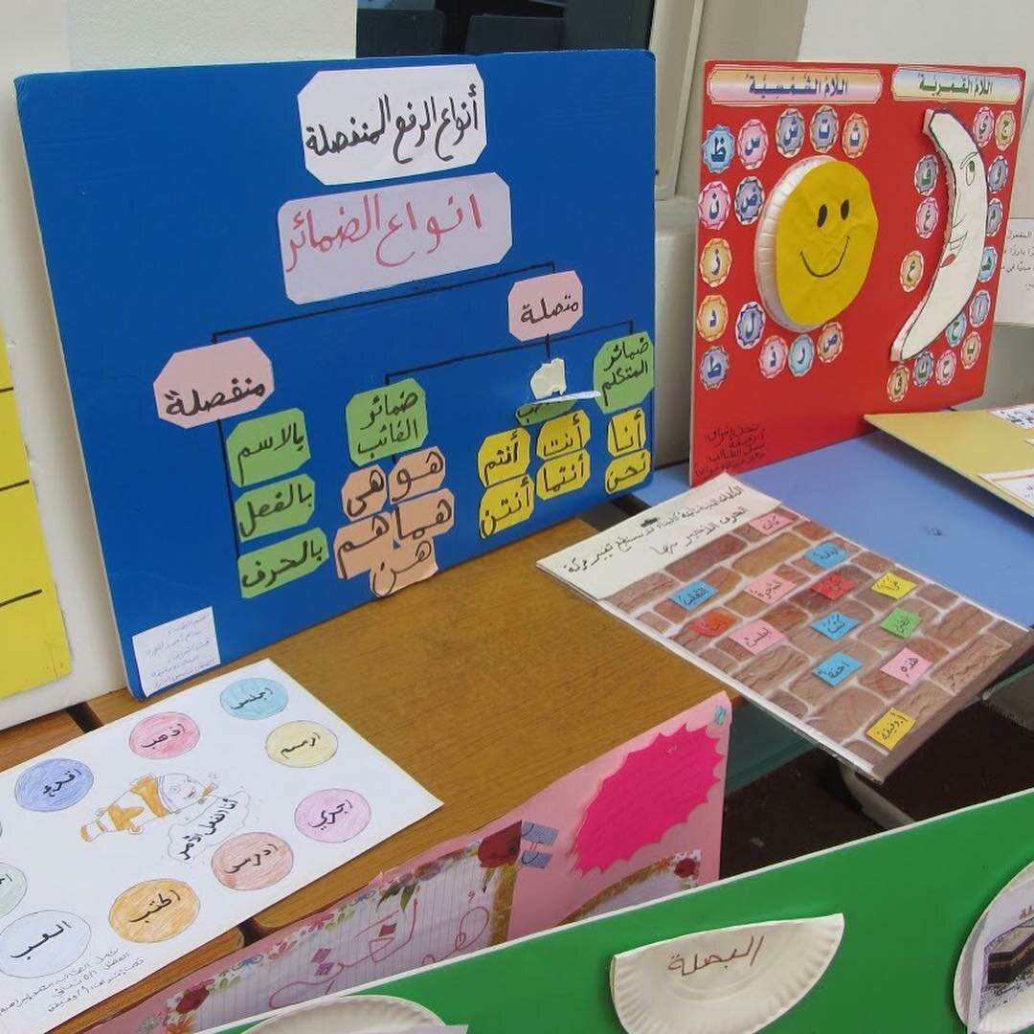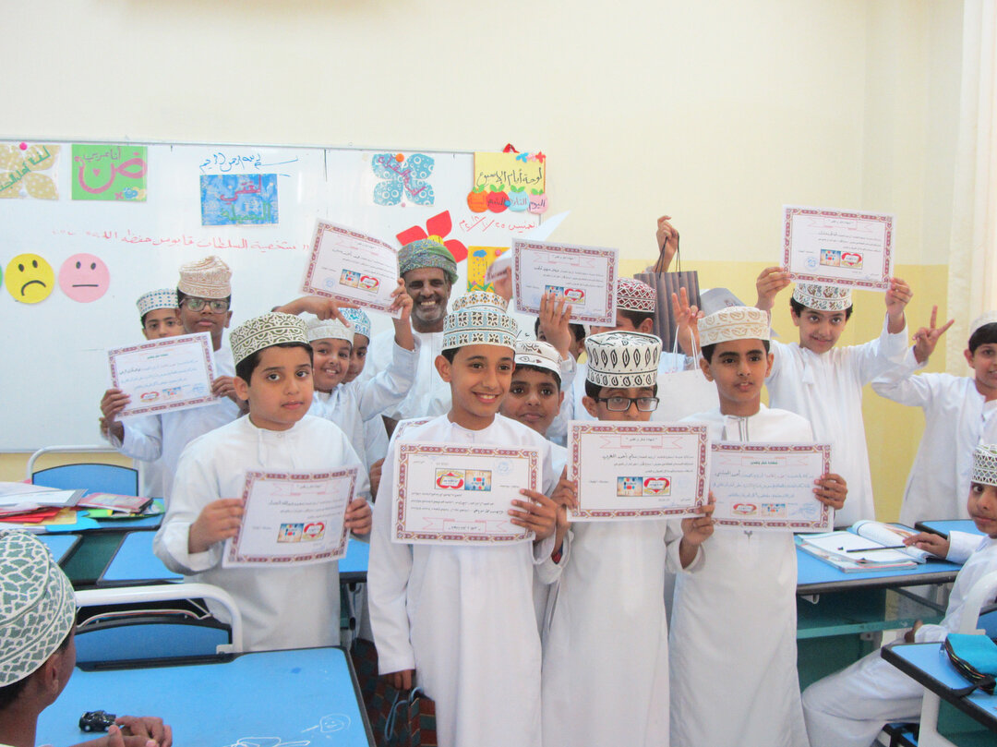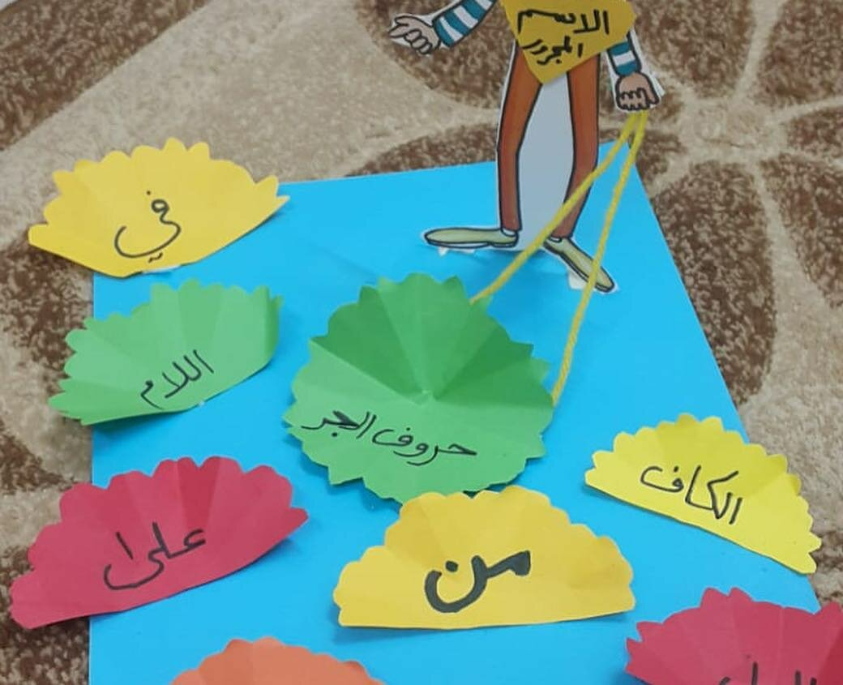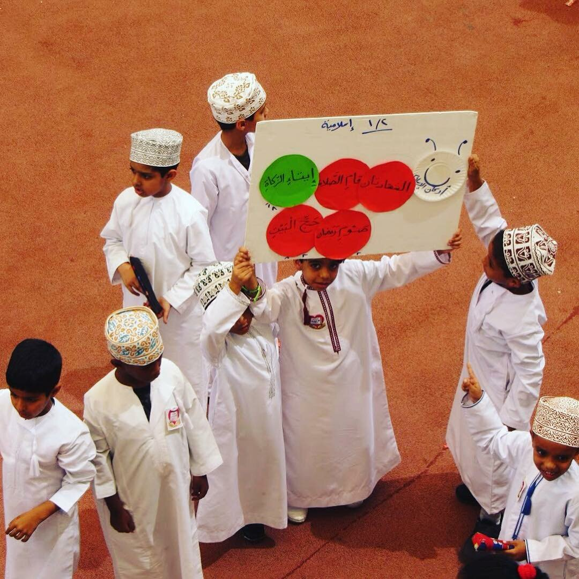

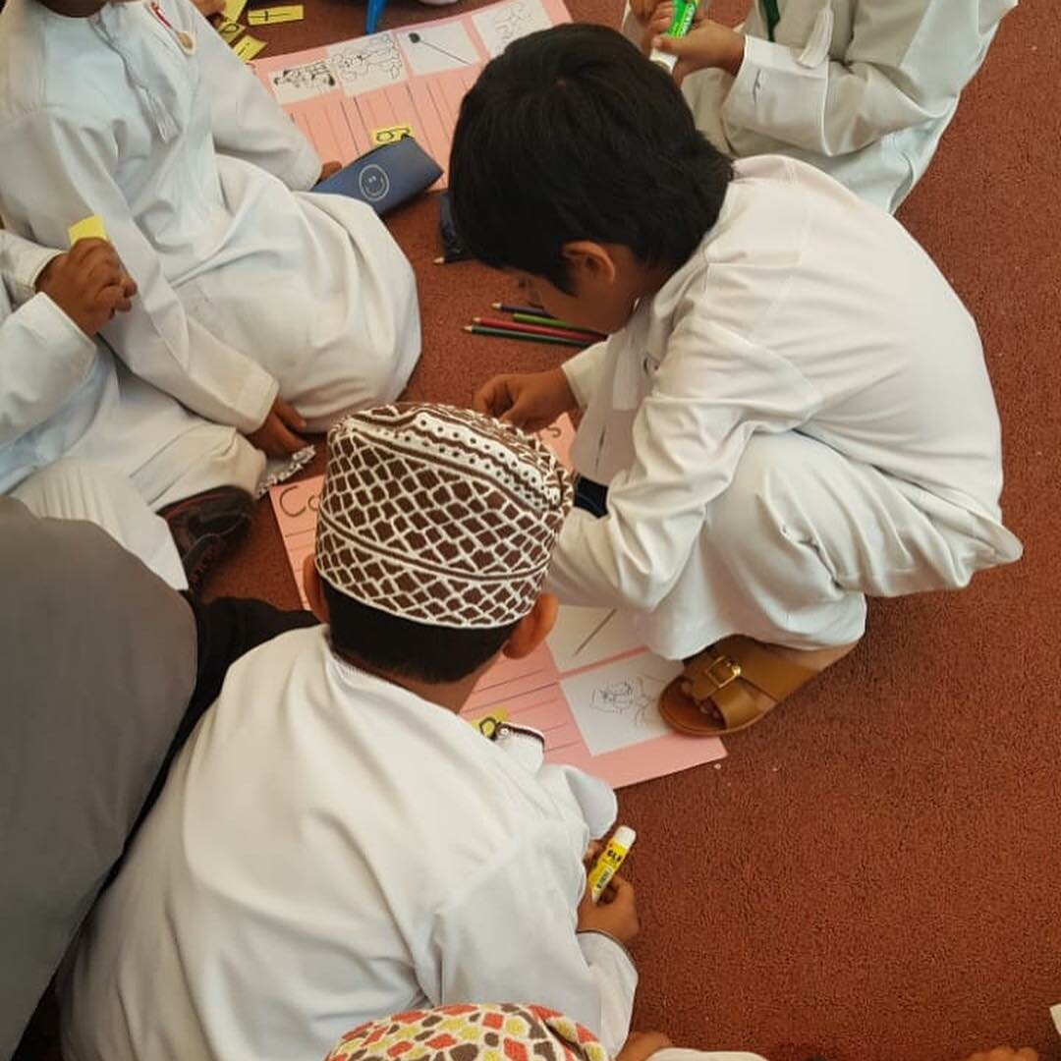

### SAMAHRAM BILINGUAL PRIVATE SCHOOL

**Videos**

## ALUMNI

**Alumni**

**Under Constructions….**

## CAREER

## CURRENT OPENING

##### Jobs opening for 2019-2020:

The school requires well-qualified and experienced teachers in the following subjects to teach Monolingual and Bilingual classes.

 Bilingual teachers must have IELTS Band 6 or TOEFL score 600 except for English which must be IELTS Band 7 or TOEFL score 700.  
 Bachelor€™s degree with specialization subject.  
 Minimum experience required 2 years in recognized educational institution.  
 All the documents of qualification and experience must be attested by the Ministry of External Affairs of their respective country and further attested by the Ministry of Foreign Affairs, Oman.

## CONTACT

### CHAIRMAN

#### Dr. Ahmed bin Ali Al-Mashani

#### Email: drahmed@samharam.edu.om For any complaint / Suggestion that needs immediate attention of SMC and Principal For any complaint / Suggestion that needs immediate attention of SMC and Principal For any innovative teaching ideas that you have read or seen and want us to know and brainstorm,

### SCHOOL MANAGEMENT

#### Sheik.Salem bin Ali Amer Jeed / Sheik.Salem Mubarak Al Shanfari

#### Email: committee@samhram.edu.om For any complaint / Suggestion that needs immediate attention of SMC and Principal For any complaint / Suggestion that needs immediate attention of SMC and Principal For any innovative teaching ideas that you have read or seen and want us to know and brainstorm,

### PRINCIPAL

#### Zainab Al Shanfari

#### Email address: principal@samharam.edu.om For any complaint / Suggestion that needs immediate attention of SMC and Principal For any complaint / Suggestion that needs immediate attention of SMC and Principal For any innovative teaching ideas that you have read or seen and want us to know and brainstorm,

### GUIDANCE COUNSELOR

#### Asma Al Shanfari

#### Email address: counceller@samharam.edu.om For any complaint / Suggestion that needs immediate attention of SMC and Principal For any complaint / Suggestion that needs immediate attention of SMC and Principal For any innovative teaching ideas that you have read or seen and want us to know and brainstorm,

